# AcqManager

**View Manu (Display Waveform Online or in Run-Time)**

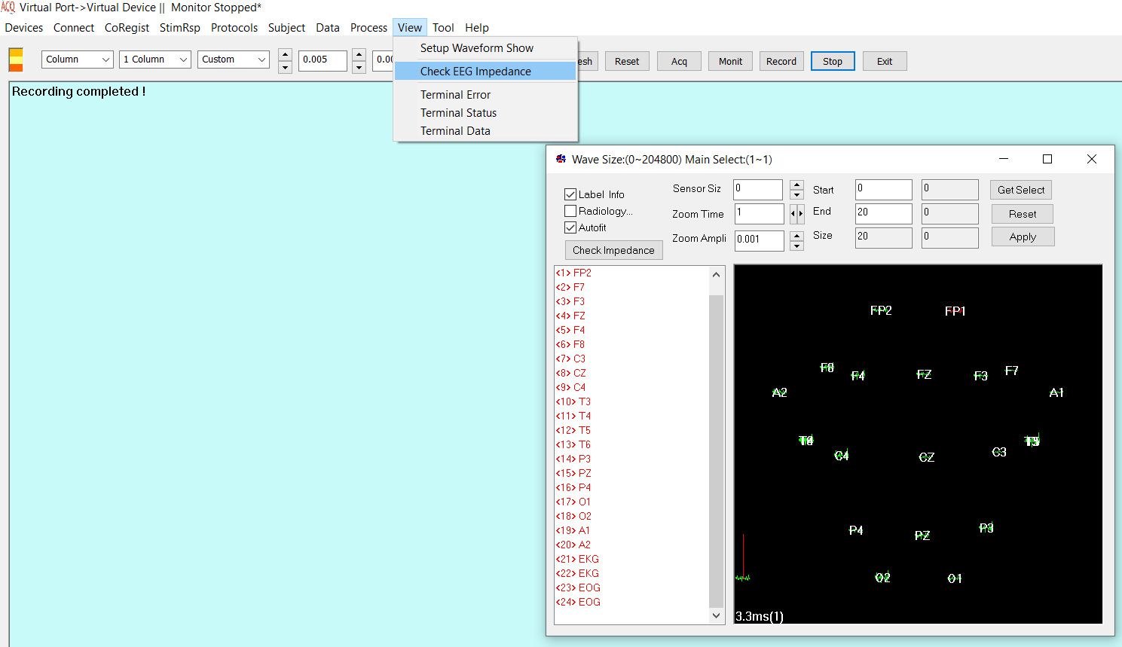

# DISCLAIMER

We have used reasonable effort to include accurate and up-to-date information in this manual; it does not, however, make any warranties, conditions or representations as to its accuracy or completeness. We assume no liability or responsibility for any errors or omissions in the content of this manual. Your use of this manual is at your own risk. Under no circumstances and under no legal theory shall the authors be liable for any indirect, direct, special, incidental, punitive, exemplary, aggravated or consequential damages arising from your use of this manual.

Features and specifications of this software program are subject to change without notice. This manual contains information and images about AcqManager, its user interface, GUI and its other signal processing algorithms, publications that are protected by copyright.

All rights reserved. This publication may be reproduced, stored in a retrieval system, or transmitted, in any form or by any means, electronic, mechanical, photocopying, recording, or otherwise, with prior permission by the authors.

*Sending Your Comments and Critiques:* We’d like to hear from you. Your comments and suggestions for improving this document are welcome and appreciated. Please e-mail your feedback to support@mecurer.com

Thank you.

Contents

AcqManager 1

DISCLAIMER 2

Contents 3

*Warnings and Cautions* 4

Preface 5

Setup Waveform Show 6

Check EEG Impedance 7

Terminal Error 8

Terminal Status 9

Terminal Data 9

# *Warnings and Cautions*

This software supports data acquisition for magnetoencephalography (MEG), electroencephalography (EEG) and other bioelectromagnetic signals. Though MEG and EEG waveforms appear similar, they have different unit in amplitude. If the MEG and EEG data recorded simultaneously, their time unit or temporal resolution is typically the same.

Modern MEG/EEG systems typically have MEG/EEG sensor/electrode channels as well as other channels. For example, trigger channel, head-localization channels and additional ADC (analog-to-digital) channels. To avoid problems, please pay attention to the channel names and the amplitude value/unit. Their values may be of different orders of magnitude. Unexpected results may occur if their values are mixed in measurements.

When performing waveform analysis, regardless of whether MEG or EEG or both are displayed, ensure that the data are appropriately filtered with DC-offset/linear-trend removal. If the waveforms had very large amplitude (e.g. > 3 pt), it is recommended that you identify possible noise.

There are a set of source localization algorithms in the program. Each source localization algorithm has been designed and tested for specific reasons. To ensure the quality and visibility, all source localization algorithms will generate a volumetric source image, which can be considered as an image with millions of “dipoles” or multi-value-voxel, which is significantly different from the conventional magnetic source imaging (MSI) or equivalent current dipoles.

Head movement during MEG recordings may affect the accuracy of source imaging. If subjects move too much during MEG recordings, the MEG results are more than likely poor.

The accuracy of the structural images (MRI/CT) may also affect the MEG results if the conventional magnetic source imaging (MSI) is used. If MRI/CT is distorted, the combination of MEG/MRI/CT will be low-quality. In addition, multiple local sphere, head model or other structural constrained source localization my internally use the MRI/CT images. Any analysis based on those distorted images may yield unexpected or poor results.

The following warnings and cautions appear in this guide. Please ensure you are aware of all the operations and interpretations.

# Preface

The Main Frame is one of the core windows of AcqManager software. It is used as the primary tool to view MEG, EEG, MCG, ECG, triggers and other data, mark and classify the data, and identify results of interest for academic or clinical purposes. Importantly, the Main Frame provides graphic user interface (GUI) for access other function. In other words, it is also often used to launch other windows such as source localization.

This guide describes the operation of the AcqManager application for MEG/EEG/MCG/ECG. Though there are many functions related to MRI/CT, analyses of MRI/CT are not the focuses of this guide.

*Determining the Software Version*

In the Main Frame: select Help -> About.

The About Dialog will show the version of the software.

*Intended Audience*

This guide is intended for anyone needing to record and view (online) data with an appropriate hardware system. It assumes the technologist/operator is familiar with standard MEG/EEG/MCG/ECG procedures and with the Windows operating systems.

*Document Structure*

Documents are generally provided in both Microsoft Word® format and Adobe® Acrobat® PDF (Portable Document Format). All editions are distributed on Flash Driver, CD or websites with the related software, and include bookmarks and hyperlinks to assist navigating the document. Please feel free to send your critiques, corrections, suggestions and comments to support@mecurer.com.

*Conventions*

Numeric: Numeric values are generally presented in decimal but in special circumstances may also be expressed in hexadecimal or binary. Hexadecimal values are shown with a prefix of 0x, in the form 0x3D. Binary values are shown with a prefix of 0b, in the form 0b00111101. Otherwise, values are presumed decimal.

Units: Units of measure are given in metric. Where measure is provided in imperial units, they are typically shown in parenthesis after the metric units. Biomagnetic signal strength is given in Teslas (T), the SI unit of flux density (or field intensity) for magnetic fields, also known as the magnetic induction. Typical signal strengths in biomagnetic measurements are in the order of pT (picoteslas = 10-12) or fT (femtoteslas = 10-15). Electrical signal strength is given in volts (V). Bioelectrical activity is typically quite small, measured in microvolts (mV).

# Setup Waveform Show

This menu provides access to define and/or modify the display of waveforms.

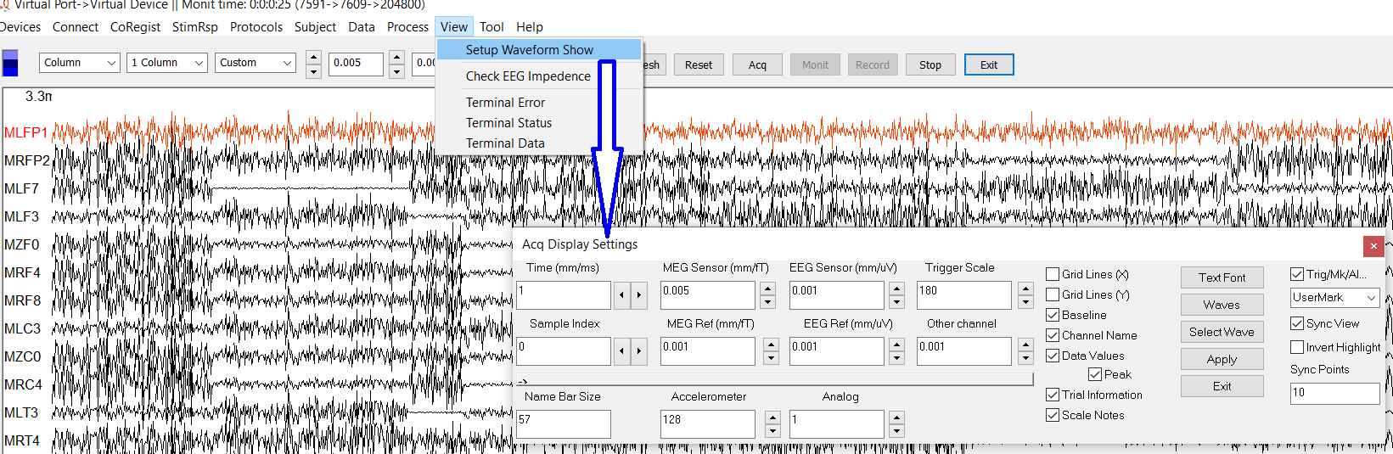Figure 1. Setup Waveform Show

The dialog of Acq Display Settings is the main window for the display. For each type of channels (e.g., MEG, EEG, Trigger), you may define different scales to show the waveforms for appropriate display. In addition, you may decide the display of name, baseline and many more. The display settings are important for EEG and MEG. Here are some basic information for setup for EEG.

The EEG (electroencephalogram) is a recording of the electrical activity of the brain from the scalp. The recorded waveforms reflect the cortical electrical activity. EEG activity is quite small, measured in microvolts (mV). The main frequencies of the human EEG waves are:

Delta: has a frequency of 3 Hz or below. It tends to be the highest in amplitude and the slowest waves. It is normal as the dominant rhythm in infants up to one year and in stages 3 and 4 of sleep. It may occur focally with subcortical lesions and in general distribution with diffuse lesions, metabolic encephalopathy hydrocephalus or deep midline lesions. It is usually most prominent frontally in adults (e.g. FIRDA - Frontal Intermittent Rhythmic Delta) and posteriorly in children e.g. OIRDA - Occipital Intermittent Rhythmic Delta).

Theta: has a frequency of 3.5 to 7.5 Hz and is classified as "slow" activity. It is perfectly normal in children up to 13 years and in sleep but abnormal in awake adults. It can be seen as a manifestation of focal subcortical lesions; it can also be seen in generalized distribution in diffuse disorders such as metabolic encephalopathy or some instances of hydrocephalus.

Alpha: has a frequency between 7.5 and 13 Hz. Is usually best seen in the posterior regions of the head on each side, being higher in amplitude on the dominant side. It appears when closing the eyes and relaxing, and disappears when opening the eyes or alerting by any mechanism (thinking, calculating). It is the major rhythm seen in normal relaxed adults. It is present during most of life especially after the thirteenth year.

Beta: beta activity is "fast" activity. It has a frequency of 14 and greater Hz. It is usually seen on both sides in symmetrical distribution and is most evident frontally. It is accentuated by sedative-hypnotic drugs especially the benzodiazepines and the barbiturates. It may be absent or reduced in areas of cortical damage. It is generally regarded as a normal rhythm. It is the dominant rhythm in patients who are alert or anxious or have their eyes open.

Frequency refers to rhythmic repetitive activity (in Hz). The frequency of EEG activity can have different properties including:

Rhythmic. EEG activity consisting in waves of approximately constant frequency.

Arrhythmic. EEG activity in which no stable rhythms are present.

Dysrhythmic. Rhythms and/or patterns of EEG activity that characteristically appear in patient groups or rarely or seen in healthy subjects.

Voltage refers to the average voltage or peak voltage of EEG activity. Values are dependent, in part, on the recording technique. Descriptive terms associated with EEG voltage include:

Attenuation (synonyms: suppression, depression). Reduction of amplitude of EEG activity resulting from decreased voltage. When activity is attenuated by stimulation, it is said to have been "blocked" or to show "blocking".

Hypersynchrony: Seen as an increase in voltage and regularity of rhythmic activity, or within the alpha, beta, or theta range. The term implies an increase in the number of neural elements contributing to the rhythm. (Note: term is used in interpretative sense but as a descriptor of change in the EEG).

Paroxysmal : Activity that emerges from background with a rapid onset, reaching (usually) quite high voltage and ending with an abrupt return to lower voltage activity. Though the term does not directly imply abnormality, much abnormal activity is paroxysmal.

Morphology refers to the shape of the waveform. The shape of a wave or an EEG pattern is determined by the frequencies that combine to make up the waveform and by their phase and voltage relationships. Wave patterns can be described as being:

Monomorphic. Distinct EEG activity appearing to be composed of one dominant activity

Polymorphic. distinct EEG activity composed of multiple frequencies that combine to form a complex waveform.

Sinusoidal. Waves resembling sine waves. Monomorphic activity usually is sinusoidal.

Transient. An isolated wave or pattern that is distinctly different from background activity.

a) Spike: a transient with a pointed peak and a duration from 20 to under 70 msec.

b) Sharp wave: a transient with a pointed peak and duration of 70-200 msec.

Synchrony refers to the simultaneous appearance of rhythmic or morphologically distinct patterns over different regions of the head, either on the same side (unilateral) or both sides (bilateral).

Periodicity refers to the distribution of patterns or elements in time (e.g., the appearance of a particular EEG activity at more or less regular intervals). The activity may be generalized, focal or lateralized.

# Check EEG Impedance

A measure of the impediment to the flow of alternating current, measured in ohms at a given frequency. Larger numbers mean higher resistance to current flow. The higher the impedance of the electrode, the smaller the amplitude of the EEG signal. In EEG studies, should be at lest 100 ohms or less and no more than 5 kohm.

Figure 2. Check EEG Impedance

# Terminal Error

This function is designed for diagnostic purposes. In case the data acquisition is sluggish, the terminal may reveal some errors.

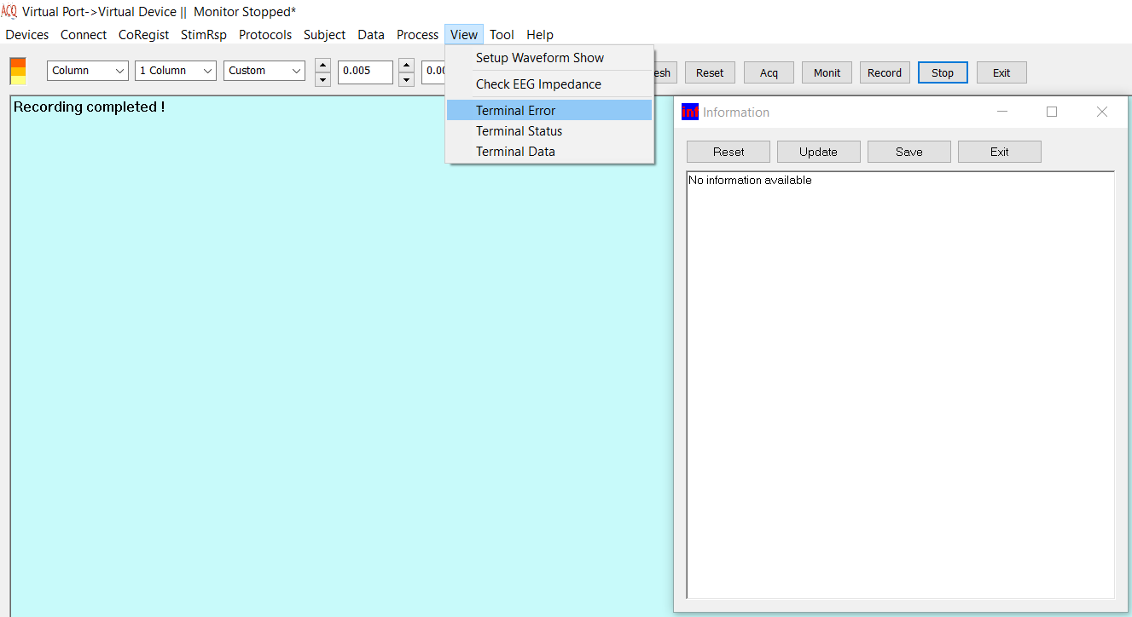

Figure 3. Terminal Error provide a window for observe the internal error of the data acquisition.

# Terminal Status

This function is designed to check the status of magnetic sensors or electrodes. In case the data recorded with AcqManager have some noise, this function may reveal the problem (e.g., the hardware problem).

# Terminal Data

Data (signals) are typically displayed in the main window. However, for troubleshooting, this function may provide the number of the data for identifying the problem.

**Index**

E

Electroencephalography (EEG), **5**

F

femtoteslas, 6

M

Magnetic source imaging (MSI), 5

Magnetoencephalography (MEG), 5

Main Frame, 6

P

picoteslas, 6

T

Teslas (T),, 6